

**National University**



of Computer

and

Emerging Sciences

Chiniot

-

Faisalabad Campus



**EE1005 – Digital Logic Design**

**Quiz# 3**

**Instructor:** Muhammad Adeel Tahir **Section:** SE – 2A **Time:** 20 Minutes

**Name: _____________________________**

**Roll No: ____________________________ Total: 20 marks**

***Note:*** *Use the back side of the page if needed. Make sure the handwriting is neat while drawing the circuit, quiz will be marked as 0 if attempted in a writing that is not readable at all.* ***Cutting will result in negative marking.***

**Q1: Draw a NAND logic diagram that implements the complement of the following function, use 2 input NAND gate for your implementation, label each output of gate carefully to avoid deduction of marks. Use the given k-map box, avoid cutting to show proper groupings. (5+5 = 10 marks)**

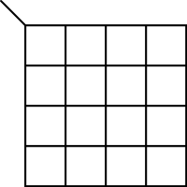

**G(A,B,C,D) = ______________**

**Circuit Diagram:**

**Q2: Implement and draw circuit for the following Boolean function F, together with the don’t-care conditions d, using no more than two NOR gates. Use the given k-map box, avoid cutting to show proper groupings. (5+5 = 10 marks)**

